Patient Health Monitor Portal

Contents

Use Cases …………………………………………………………………………………………………………………………………………….3

Class Diagram ………………………………………………………………………………………………………………………………………3

Sequence Diagram ……………………………………………………………………………………………………………………………….4

Database Design ………………………………………………………………………………………………………………………………. 10

UIScreens………………………………………………………………………………………………………………………………………………12

Uses Cases

PHMP_01: As a patient, I should able to login my page to do all activities.

PHMP_02: As a patient, I should able to register myself into application.

PHMP_03: As a patient, I can update or create the profile.

PHMP_04: As a patient, after login I should able to enter the data to check the BMI, Diabetes, Blood count.

Class Diagram:

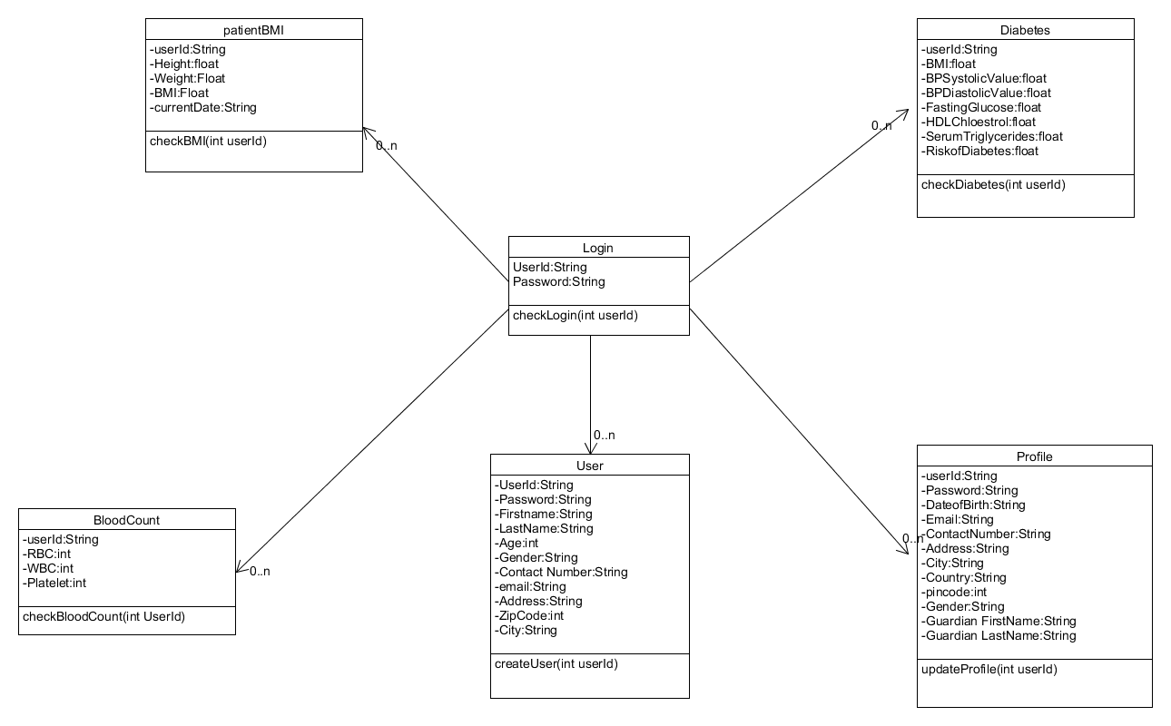

Sequence Diagram:

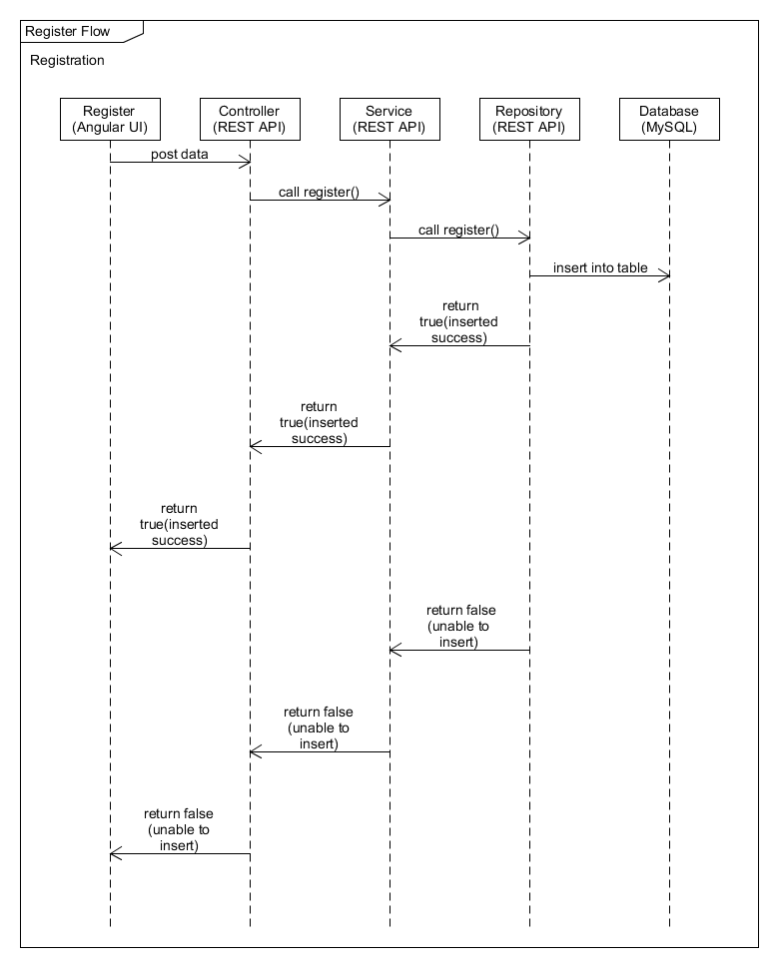

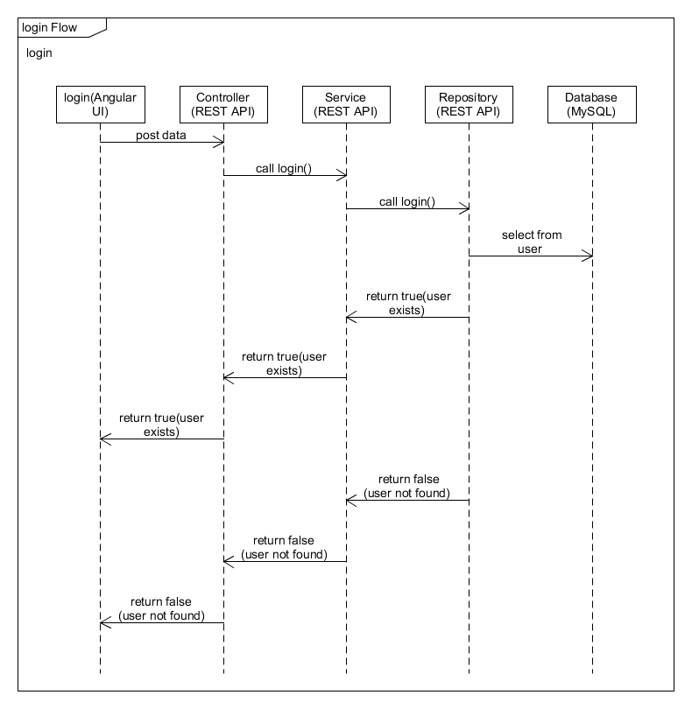

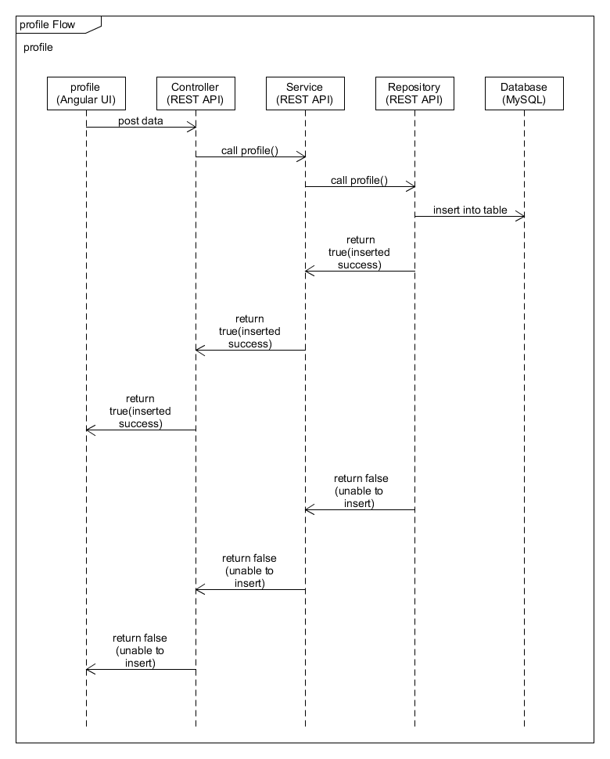

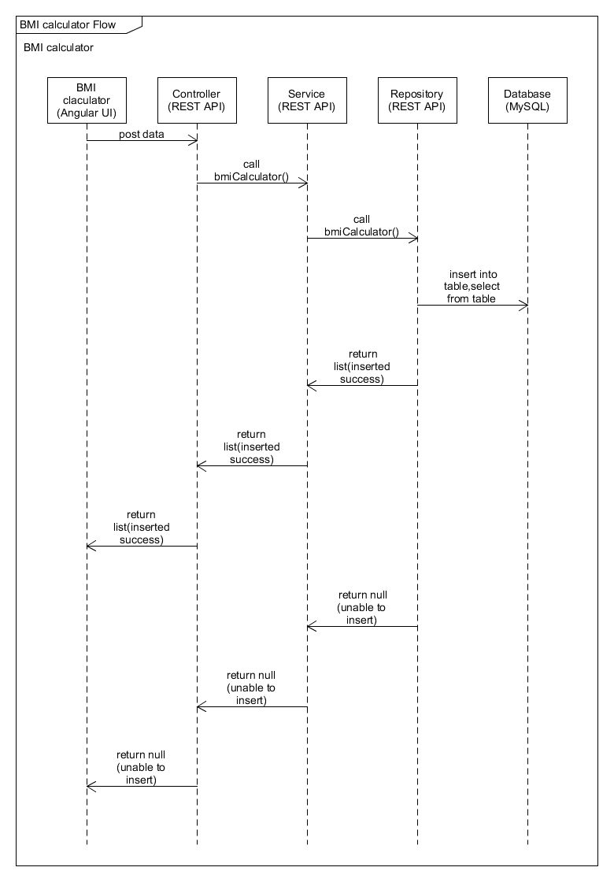

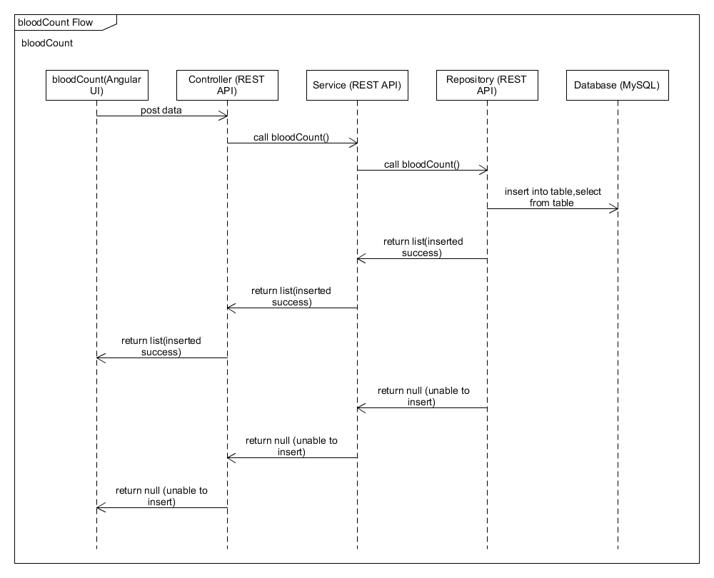

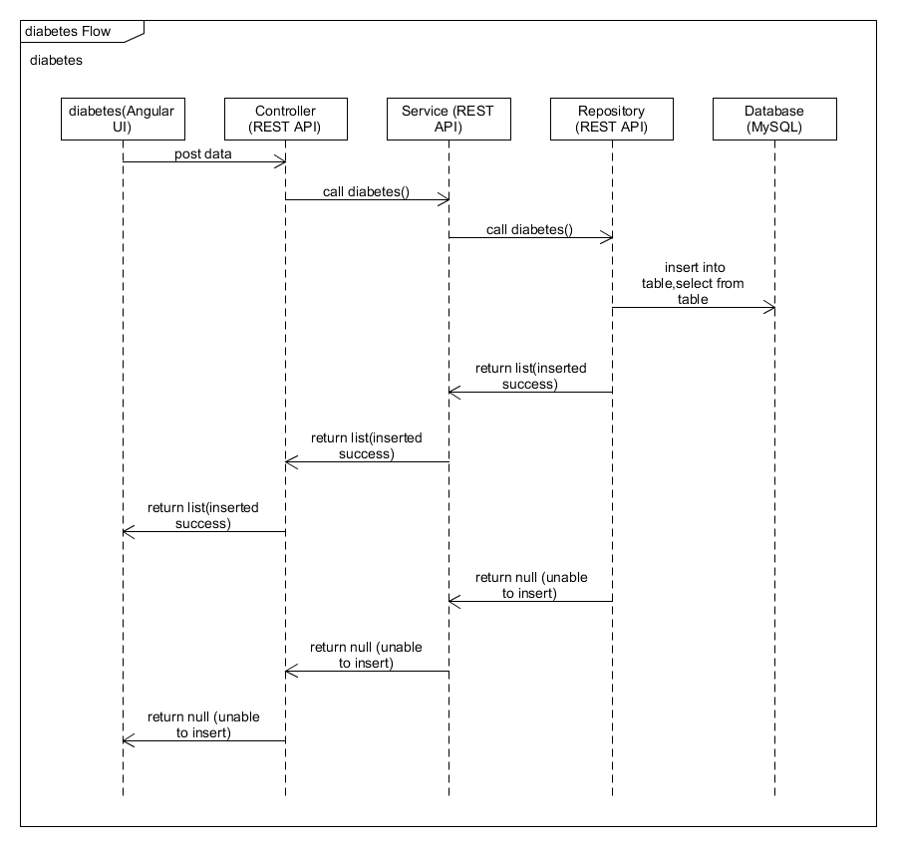

Database Designs

User:

|  |  |  |
| --- | --- | --- |
| Column Name | Data Type | Constraints |
| Id | Int | Not Null |
| Password | Varchar(15) | Not Null |
| First Name | Varchar(15) | Not Null |
| Last Name | Varchar(15) | Not Null |
| Age | Int | Not Null |
| Gender | Varchar(5) | Not Null |
| Contact Number | Varchar(10) | Not Null |
| Email | Varchar(15) | Unique |
| Address | Varchar(50) | Not Null |
| Zip Code | Int | Not Null |
| City | Varchar(15) | Not Null |

Patient Profile

|  |  |  |
| --- | --- | --- |
| Column Name | Data Type | Constraints |
| User Id | Int | Primary Key |
| Password | Varchar(15) | Not Null |
| Date Of Birth | Date | Not Null |
| Email Id | Varchar(15) | Not Null, Unique |
| Contact Number | Varchar(10) | Not Null |
| Address | Varchar(15) | Not Null |
| City | Varchar(10) | Not Null |
| Country | Varchar(15) | Not Null |
| Pin code | Int | Not Null |
| Gender | Varchar(5) | Not Null |
| Guardian First Name | Varchar(15) | Not Null |
| Guardian Last Name | Varchar(15) | Not Null |

PatientBMI

|  |  |  |
| --- | --- | --- |
| Column Name | Data Type | Constraints |
| Id | Int | Primary key |
| User Id | Int | Not Null |
| Height | Float | Not Null |
| Weight | Float | Not Null |
| BMI | Float | Not Null |
| Current Date | Date | Not Null |

Blood Count

|  |  |  |
| --- | --- | --- |
| Column Name | Data Type | Constraints |
| Id | Int | Primary key |
| User Id | Int | Not Null |
| RBC | Int | Not Null |
| WBC | Int | Not Null |
| Platelet | Int | Not Null |

Diabetes

|  |  |  |
| --- | --- | --- |
| Column Name | Data Type | Constraints |
| Id | Int | Primary key |
| UserId | Int | Not Null |
| BMI | Float | Not Null |
| BP Systolic Value | Float | Not Null |
| BP Diastolic Value | Float | Not Null |
| Fasting Glucose | Float | Not Null |
| HDL Cholesterol | Float | Not Null |
| Serum Triglycerides | Float | Not Null |
| Risk of Diabetes | Float | Not Null |

UI Screens

Patient Health Monitor Portal

Register

Password

First Name

Last Name

cbchwgqdkfjfbrvf

Password

Register

City

ZipCode

Address

Email Id

Contact Number

Gender

Age

Java mode 2 HCL Training –Final Case Study

UI Screens

Patient Health Monitor Portal

Register

Password

Please enter the First Name

First Name

Last Name

Please enter the Last Name

cbchwgqdkfjfbrvf

Please enter Password

Password

Please enter contact number

Please enter city

Please enter zip code

Please enter address

Please enter email Id

Please enter gender

Please enter age

City

Zip Code

Address

Email Id

Contact Number

Gender

Age

Register

Java mode 2 HCL Training –Final Case Study

Login

Java Mode2 HCL Training – Final Case Study

New User? SignUP

Password

User Id

Login

Patient Health Monitor Portal

Login

## Login - Error1(If fields are empty)

Patient Health Monitor Portal

Login

<User Id>

<password>

Login

Java Mode 2 HCL Training – Final Case Study

New User? SignUp

User Id

Please enter the User name

Password

Please enter the Password

Login- Error2(if fields are incorrect )

User Id

Patient Health Monitor Portal

Login

<User Id>

<password>

Login

Java Mode 2 HCL Training – Final Case Study

New User? Sign Up

User Id

Password

Invalid Credentials

Patient Profile

Java Mode2 HCL Training – Final Case Study

Guardian Last Name

Guardian First Name

Gender

Pin Code

Country

City

Address

Contact Number

Email Id

DOB

Password

User Id

Patient Profile

Patient Health Monitor Portal

Home

Update

Patient Profile(if fields are empty)

Java Mode2 HCL Training – Final Case Study

Patient Profile

Patient Health Monitor Portal

Home

Please enter user Id

Username

Please enter password

Password

Please enter DOB

DOB

Please enter email Id

Email Id

Please enter contact Number

Contact Number

Please enter address

Address

Please enter city

City

Please enter country

Country

Pin Code

Please enter Pin code

Gender

Please enter gender

Please enter guardian first name

Guardian First Name

Please enter guardian last name

Guardian Last Name

Update

Patient Body Mass Index Calculator

SP



Java Mode2 HCL Training – Final Case Study

BMI

Patient Health Monitor Portal

User Id

Height

Weight

Submit

Patient Body Mass Index Calculator(Error)

SP



Java Mode2 HCL Training – Final Case Study

BMI

Patient Health Monitor Portal

User Id

Please enter User Id

Please enter height

Height

Please enter weight

Weight

Submit

Blood Glucose Level

Java Mode2 HCL Training – Final Case Study

Submit

Platelet Count

WBC count

RBC Count

User Id

Blood Glucose Level

Patient Health Monitor Portal

Home

Blood Glucose Level(Error)

Java Mode2 HCL Training – Final Case Study

Blood Glucose Level

Patient Health Monitor Portal

Home

Please enter User Id

User Id

Please enter rbc count

RBC Count

Please enter wbc count

WBC count

Please enter platelet count

Platelet Count

Submit

Diabetes Risk Calculator

Home

Submit

Java Mode2 HCL Training – Final Case Study

HDL cholesterol Reading

Serum Triglycerides

Fasting Glucose Reading

BP Diastolic Value

BP Systolic Value

Diabetes Risk Calculator

Patient Health Monitor Portal

Diabetes Risk Calculator(Error)

Please enter serium triglycerides

Please enter cholesterol reading

Please enter glucose reading

Please enter bp diastolic value

Serum Triglycerides

HDL cholesterol Reading

Fasting Glucose Reading

BP Systolic Value

BP Diastolic Value

Please enter bp systolic value

Please enter

Submit

Home

Java Mode2 HCL Training – Final Case Study

Diabetes Risk Calculator

Patient Health Monitor Portal